**Quantifying HOX-2 Protein Expression in the Rat Brain**

**Introduction**

The brain sections shown here are from a pilot study I ran several months ago to look at changes in the expression of a particular protein in the rat brain after sexual experience. This protein is Heme Oxygenase 2 (HOX-2), an enzyme that cleaves heme molecules (the oxygen carrying molecules in mammalian blood) to produce several byproducts, including carbon monoxide (CO), a gaseous molecule that can act as a neurotransmitter.

The basis of this study is to assess the expression of HOX-2 in the rat brain and to compare it with findings from a previous study looking at the nitric oxide synthase (NOS) enzyme, which is responsible for the production of nitric oxide (NO), another gaseous neurotransmitter. A previous study [1] found that NOS levels rise in the medial preoptic area (MPOA) of rats after repeated sexual experiences when compared to controls. The MPOA is a region of the hypothalamus that is important for numerous sexual behaviors in male vertebrates. Subsequent studies found that NO neurotransmission acts by stimulating dopamine release in the MPOA [2] via a complex molecular mechanism [3]. CO shares several molecular pathways with NO and has also been shown to modify neurotransmitter levels [4].

**Hypothesis 1**

Since CO is similar to NO, it may also be important for the regulation of sexual behavior. *We hypothesize that there will be an increase in HOX-2 expression in the MPOA in sexually experienced animals when compared to controls (no sex experience).* To do this, we will have to take photomicrographs of the MPOA of naïve and sexually experienced animals and assess whether the experienced animals have more or less HOX-2 expression in terms of either cell counts or densitometry (measuring how darkly stained the area is).

**Hypothesis 2**

The dorsal striatum (also called the caudate putamen or CPu) is an area of the brain that is important for numerous types of learning and behavior. The degeneration of cells in this brain region is responsible for the dementia associated with Huntingson’s disease, and the death of dopamine neurons that project to this region causes the motor symptoms associated with Parkinson’s disease. A series of studies by Bernard Balleine and colleagues [5] illustrated the importance of this brain region in controlling both deliberate and habitual actions, including complex motor behaviors (which could include sex). Since NO is important in regulating plasticity in this region [6] CO may also fulfill a similar role. *We hypothesize that there will be a shift in HOX-2 expression within the dorsal striatum that reflects a functional change within the circuitry of this brain area.* To assess this hypothesis, we will take photomicrographs from two areas of the dorsal striatum – the medial end abutting the lateral ventricle and the lateral end abutting the corpus callosum – and analyze our pictures across both region and group.

**Quantifying HOX-2 Expression in the Brain**

The expression of proteins or genes in the brain cannot be assessed without special staining techniques. In this case, I have used a technique called immunocytochemistry to tag the protein of interest (HOX-2) with antibodies and then make those antibodies visible through a special stain. Prior to staining, the tissue is frozen and sectioned into 30 µm-thick coronal sections (coronal cuts are seen at the right below). After staining, the tissue is mounted onto a microscope slide like so:

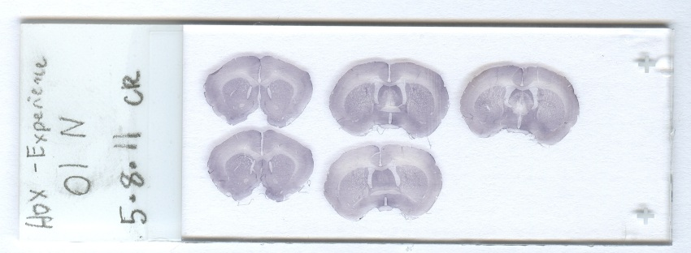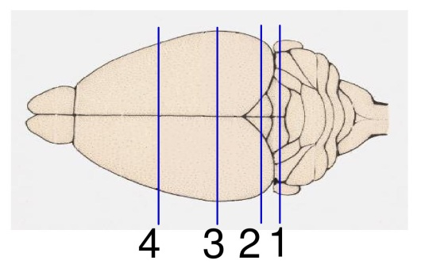

A close-up of the coronal section in the top-middle of this slide is shown below. This section is located just behind line 4 in the rat brain schematic above. Images like this are created by taking many individual photographs of the brain and using a computer program to form a composite mosaic of the series. The three black boxes in the image below show the approximate size of a single photomicrograph taken at 100x magnification. These three boxes represent the MPOA (A), medial portion of the CPu (B), and lateral portion of the CPu (C), respectively.

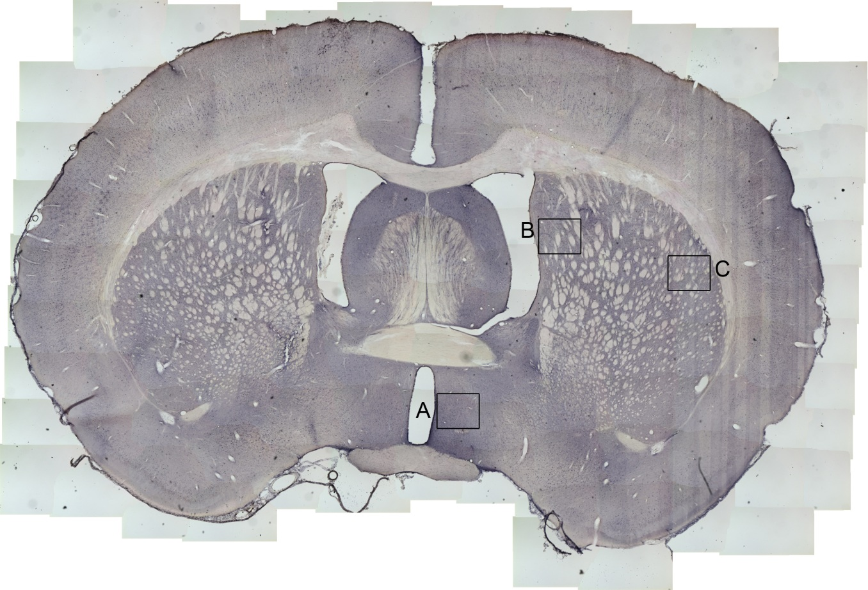

The image below is a photomicrograph of the lateral part of the CPu (lCPu). The light oblong area near the middle of the screen is part of a blood vessel running through the brain. The textured white blobs interspersed throughout the image are mostly bundles of axons that pass through the CPu on their way from the cerebral cortex to the thalamus (corticothalamic bundles); these are mostly made of fatty myelin surrounding the axons and don’t express much protein. The remainder of this image is comprised of gray matter comprised of cell bodies without much myelin. The dark spots are cells that are expressing high levels of HOX-2, our protein of interest.

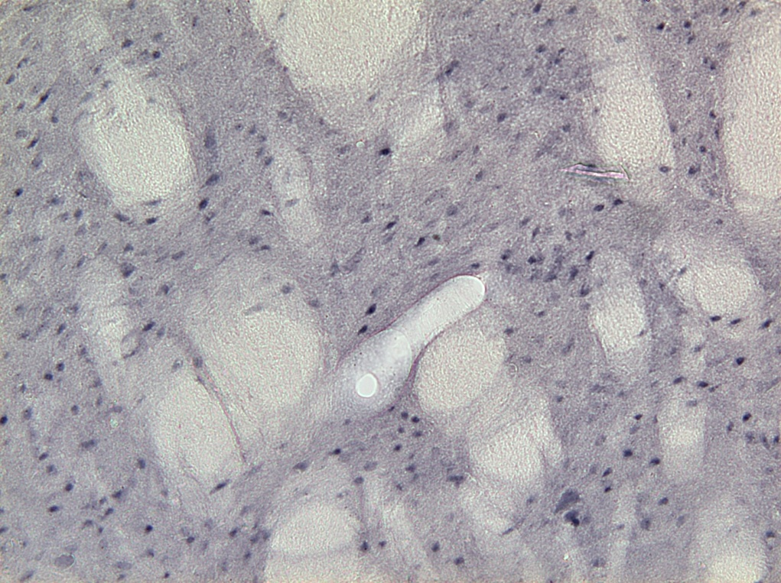

To determine how much HOX-2 there is in this brain section, you can either assess the overall darkness of the photograph (densitometry) or count the number of cells in the picture (cell counts). Either measure can be seen in the literature, but cell counts are generally preferred when individual cells are readily identified, as in the image above. I use the program ImagePro Plus 7.0 to count cells.

The image below is a screenshot from the ImagePro program showing a manual counting procedure. In this procedure, the counter simply clicks on each sufficiently dark cell and the computer program tallies the total number of cells. If so desired, the operator can set up multiple classes to keep track of different types of cells or cells of differing degrees of darkness. This counting technique has certain advantages over automated counting – you can tag multiple classes of objects and you’re limited only by what you can see with your eye. However, manual counting can be very time-intensive and suffers from context-dependent human error.

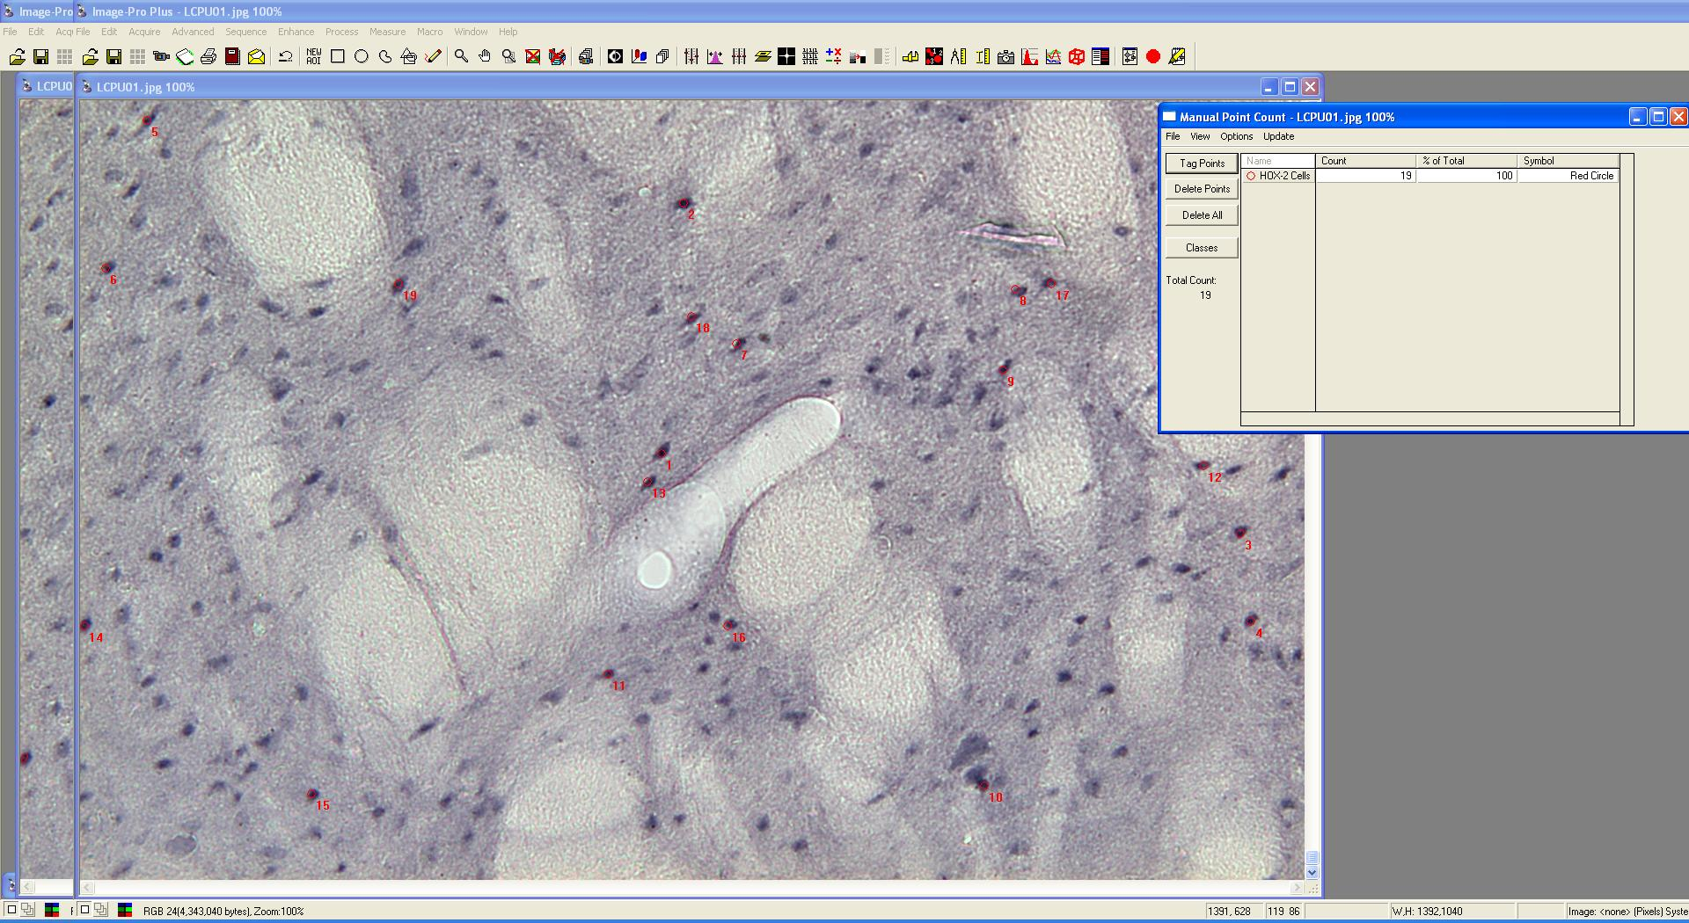

The image below is a screenshot from the ImagePro program showing an automated counting procedure. In this procedure, the operator sets boundary conditions such as cell size and color, which the program then uses to extract a cell count from the image. Automated counting is fast and extremely reliable but is completely context-independent, so the counts occasionally need to be manually adjusted by the human operator, such as an instance where several bubbles or globs of grime are present on the slide and the computer mistakes these for cells. Automated counts are most effective when there is good contrast between the objects being counted (cells) and the surrounding background, but tend to make mistakes in noisy or low-contrast pictures. You should fine-tune your counting algorithm before counting a set of pictures to make sure your cell counts are in the range of those obtained by an experienced human counter.

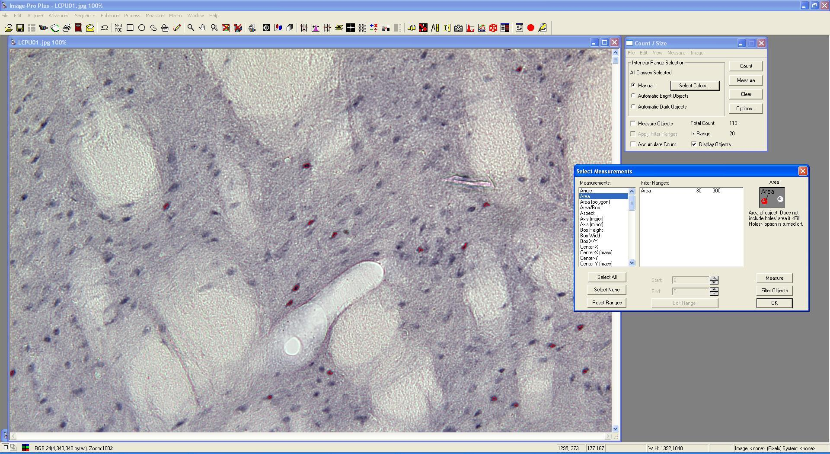

The cell count you’ve arrived at for a photograph represents the number of HOX-2-positive cells present in a single photomicrograph. Since each photo comprises an area of approximately 0.314 mm2 (0.648 mm wide x 0.484 mm high), you can simply divide your count by 0.314 to arrive at the *cell density* of your sample. This represents the number of HOX-2 cells per square millimeter.

**The Files**

I have provided a number of HOX-2 stained images to be used for image analysis. There are a total of 75 100x magnification photomicrographs taken from three brain regions of thirteen animals. A table summarizing the files is below:

|  |  |  |  |  |
| --- | --- | --- | --- | --- |
| **Animal** | **Group** | **MPOA Files** | **Medial CPu Files** | **Lateral CPu Files** |
| 1 | Sexually Naïve | MPOA01.JPG  MPOA02.JPG | MCPU01.JPG  MCPU02.JPG | LCPU01.JPG  LCPU02.JPG |
| 2 | Sexually Naïve | MPOA03.JPG  MPOA04.JPG | MCPU03.JPG | LCPU03.JPG |
| 3 | Sexually Naïve | MPOA05.JPG  MPOA06.JPG | MCPU05.JPG  MCPU06.JPG | LCPU05.JPG  LCPU06.JPG |
| 4 | Sexually Experienced | MPOA07.JPG  MPOA08.JPG | MCPU07.JPG  MCPU08.JPG | LCPU07.JPG  LCPU08.JPG |
| 5 | Sexually Experienced | MPOA09.JPG  MPOA10.JPG | MCPU09.JPG  MCPU10.JPG | LCPU09.JPG  LCPU10.JPG |
| 6 | Sexually Naïve | MPOA11.JPG  MPOA12.JPG | MCPU11.JPG  MCPU12.JPG | LCPU11.JPG  LCPU12.JPG |
| 7 | Sexually Naïve | MPOA13.JPG  MPOA14.JPG | MCPU13.JPG  MCPU14.JPG | LCPU13.JPG  LCPU14.JPG |
| 8 | Sexually Experienced | MPOA15.JPG  MPOA16.JPG | MCPU15.JPG  MCPU16.JPG | LCPU15.JPG  LCPU16.JPG |
| 9 | Sexually Experienced | MPOA17.JPG  MPOA18.JPG | MCPU17.JPG  MCPU18.JPG | LCPU17.JPG  LCPU18.JPG |
| 10 | Sexually Naïve | MPOA19.JPG  MPOA20.JPG | MCPU19.JPG  MCPU20.JPG | LCPU19.JPG  LCPU20.JPG |
| 11 | Sexually Naïve | MPOA21.JPG  MPOA22.JPG | MCPU21.JPG  MCPU22.JPG | LCPU21.JPG  LCPU22.JPG |
| 12 | Sexually Experienced | MPOA23.JPG | MCPU23.JPG  MCPU24.JPG | LCPU23.JPG  LCPU24.JPG |
| 13 | Sexually Experienced | MPOA25.JPG  MPOA26.JPG | MCPU25.JPG  MCPU26.JPG | LCPU25.JPG  LCPU26.JPG |

For cell counts, I generally take at least two photographs per region and average these numbers to arrive at a mean cell count. This serves to reduce variability between animals and increase the likelihood of obtaining statistical significance if there is a difference between experimental groups. In instances where only one section is available (e.g., if tissue quality in other sections is poor), you can use this singular value in lieu of the mean count.

**References**

1. Dominguez JM, Brann JH, Gil M, Hull EM. Sexual experience increases nitric oxide synthase in the medial preoptic area of male rats. Behav Neurosci. 2006 Dec;120(6):1389-94.
2. Hull EM, Dominguez JM. Getting his act together: roles of glutamate, nitric oxide, and dopamine in the medial preoptic area. Brain Res. 2006 Dec 18;1126(1):66-75.
3. Sato SM, Hull EM. The nitric oxide-guanosine 3',5'-cyclic monophosphate pathway regulates dopamine efflux in the medial preoptic area and copulation in male rats. Neuroscience. 2006 May 12;139(2):417-28.
4. Taskiran D, Kutay FZ, Pogun S. Effect of carbon monoxide on dopamine and glutamate uptake and cGMP levels in rat brain. Neuropsychopharmacology. 2003 Jun;28(6):1176-81.
5. Balleine BW, Liljeholm M, Ostlund SB. The integrative function of the basal ganglia in instrumental conditioning. Behav Brain Res. 2009 Apr 12;199(1):43-52.
6. Centonze D, Gubellini P, Pisani A, Bernardi G, Calabresi P. Dopamine, acetylcholine and nitric oxide systems interact to induce corticostriatal synaptic plasticity. Rev Neurosci. 2003;14(3):207-16.